NEIGHBOURHOOD ALERT DEV BOARD UPDATE: 60

Date: 2nd August 2021

Dear Mike Douglas,
Email: mike@visav.co.uk
Note: You are receiving this email circular because you are listed as a key contact involved with your organisation’s Neighbourhood Alert system, including senior administrators and members of the Practitioners’ Group. If you feel you should not be on this list, please reply to feedback@neighbourhoodalert.co.uk and I will remove you.

View an archive of previous updates here

Well hello from all at VISAV, I hope you are really well? I am so sorry that it has been sooo long since my last update. The reality is that it has been a hectic six months and the updates I had to give you were out of date before I got chance to send the bulitin (I know, poor excuse).

I will start with a hearty welcome to new forces (since my last update) in North Wales, Warwickshire, West Mercia and…Kent and the OPCC in Linconshire. Welcome to these brilliant new organisations, this is a periodic bulletin that I hope you find useful. I look forward to introducing you to the other members of this “Development Board” in the very near future. You will find a useful list of all live Force areas, including links and which ones are on V4 on this page: https://www.neighbourhoodalert.co.uk/AboutUs

I am not going to make this a long update, the main thing I would ask you to do is book in to the long awaited V4 update from our pilot forces Wednesday 1st September 2021 and save the date of next years in-person Conference and Award Ceremony!

Mike

Contents
Four V4 Pilot Force Areas Live 1
V4 Dev Board Pilot Review: Virtual Meeting, Book Now 1
Help Centre: New V4 Section 1
V4 Training 1
One Million Users Target 1
2020 Alert Support Ticket Summary 1
A Company With Social Values & Conscience 1
2022 Conference and Awards Dinner: Save the Date 1

Four V4 Pilot Force Areas Live
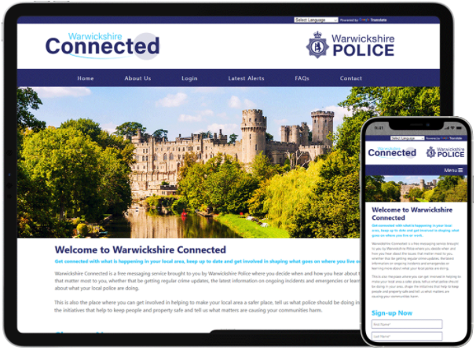 | Development of V4 has continued at a great pace and we now have four Police clients who are live on the new system (click to view the sites):  Northamptonshire:  North Wales  Warwickshire  West Mercia  The sites look great, are working well and are packed with new innovations to make registration, administration and messaging simple, quick and secure.

V4 Dev Board Pilot Review: Virtual Meeting, Book Now
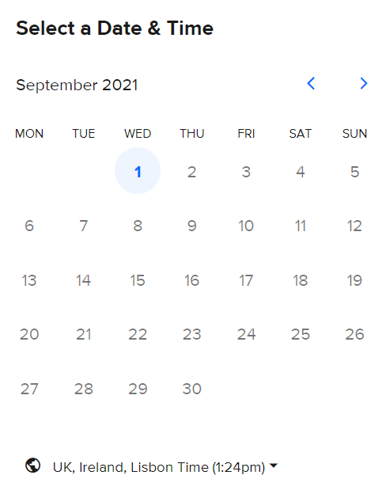 | We are delighted to invite you to the first virtual meeting to hear from key personnel from forces that have already adopted the Version 4 alert system.  Hear their honest feedback, ask questions, see a demonstration of some of the latest Main Admin and Rapport features.  The meeting is intended to enable you to make an informed decision regarding the timeline for your migration to V4.  Please use the link below to access the booking system.  https://calendly.com/visavmike/v4-dev-board-pilot-review  Note: Once you see the calendar, simply click on 1st September, and select the start time of 10am. The booking system will send you a confirmation email and a diary entry along with all the “Microsoft Teams” details.  Please feel free to share this invitation with anyone within your organisation who you feel it would be relevant to.

Help Centre: New V4 Section

As updates, tips and news will be changing regularly we have created a page within the VISAV help Centre where you can access the latest information.

This section currently features
- A video review of some of the main V4 features
- A Version Comparison document which highlights which features from V3 will be available in V4 and when.
- The latest Development Timeline / Milestone plan

Just head the Help centre from the button in the admin and search for V4 or follow the link below:
https://visavltd.zendesk.com/hc/en-gb/articles/4404614279953-The-transition-to-V4

V4 Training

In conjunction with the V4 live roll-out we are also working hard to develop a virtual training offering that will enable you to share a training link with anyone that needs support. Different sessions will be available to suit different shift patterns etc. these sessions are open to every Neighbourhood Alert client and as they cover the generic tools and reports, participants will be from different organisations (not just your own Force etc), the great news is they are provided FOC.
To see the initial sessions that are available and the “work in progress”, please use the following link:
https://www.neighbourhoodalert.co.uk/v4training

Note: We are currently recruiting and will be able to offer bespoke (chargeable) training to support your individual organisation needs if required.

One Million Users Target

As we near the milestone of one million Alert users (986,474 at the time of writing), I am asking you all to help us work towards that target by making the figure as accurate as possible. This will involve carrying out some housekeeping tasks within your system to clear out any suspended users, comms issues and incommunicados. Please feel free to email support@neighbourhoodalert.co.uk if you would like us to clear all of your suspended users etc or have any bulk housekeeping tasks you would like us to perform directly on the database.

As I have mentioned the increasing growth, I should acknowledge the amazing performance of West Mids, Lancs, Leicestershire, Humberside and West Yorkshire who all recruited over 500 new users in July. This new report only includes V3 (for now) and does highlight the huge impact of the “Enhanced Survey Module”.
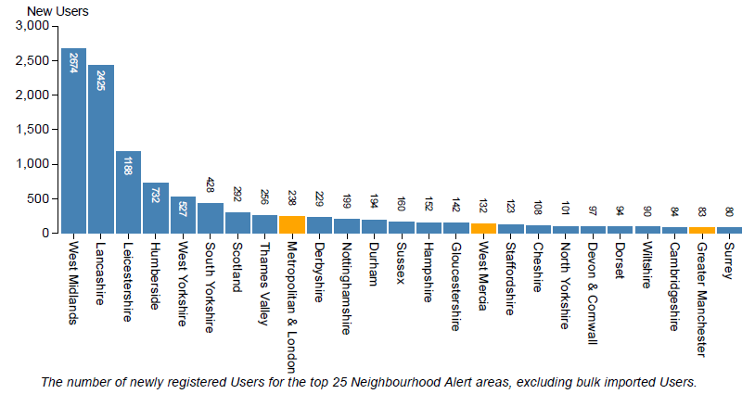

2020 Alert Support Ticket Summary

I wanted to share with you a summary of all the support requests (tickets) that we received in 2020, both from end-users and from administrators. You can see the overall stats and satisfaction scores on the graphic below and I hope you will agree that the team are doing a great job with responding to the support request as they come in.
Please note, if we receive notifications on the support desk regarding comments for the police, we respond to them quickly and explain that we (VISAV) are not in a position to assist. We signpost them to the relevant contact (Force Website, Action Fraud, online reporting etc) but in some cases, these messages do receive a poor review.

Please remember to use our support email: support@neighbourhoodalert.co.uk for all urgent and non-urgent requests
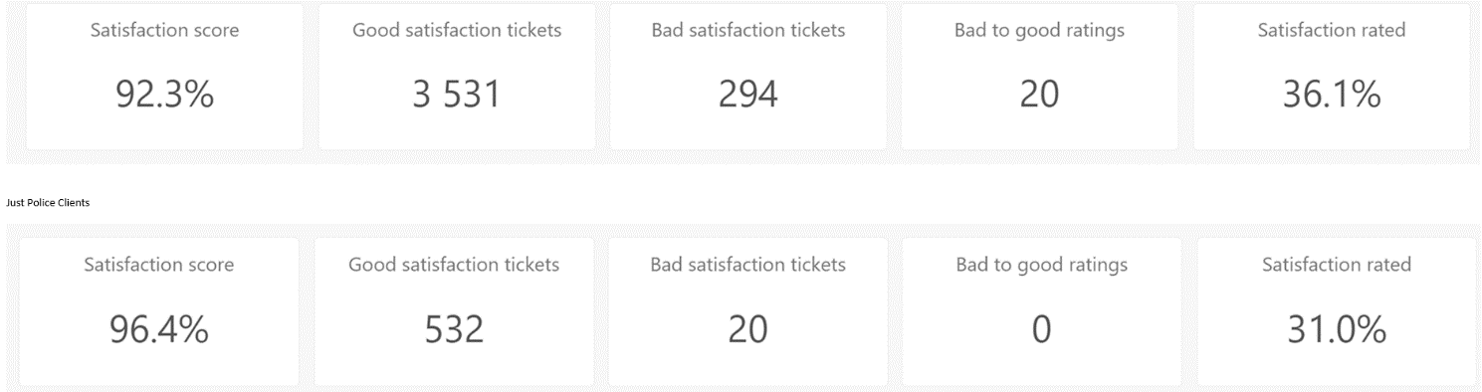

A Company With Social Values & Conscience
As a company a large proportion of our profits is dedicated to social value projects and community support. We continue to support Neighbourhood Watch nationally and throughout the country and have a network of over 100 volunteer administrators that we support in their work to ensure the national database remains the best in the country.
VISAV supports a local food bank each month financially and with volunteer hours, we also periodically support additional projects that fit with our own ethos of keeping the public safe and informed. This month that project was a donation towards roof repairs for Coventry Citizens Advice.
Review how some of your precious licence fee is being put to great use by browsing some of our community support projects here.

2022 Conference and Awards Dinner: Save the Date
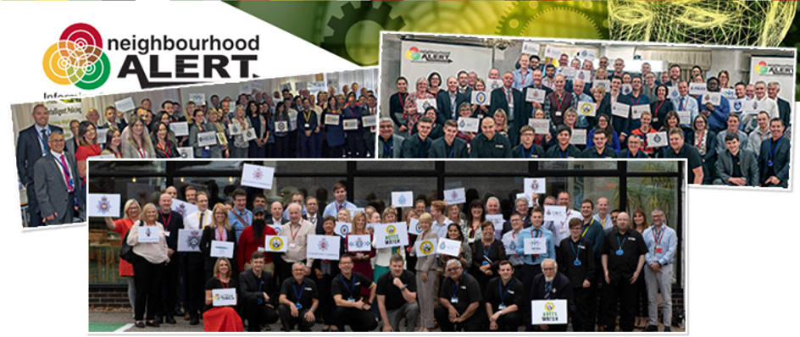 | With the country seemingly starting to return to some state of "normality", it is very much our intention to host a face-to-face conference in 2022 to celebrate everything that we have all achieved over the past couple of years.  The provisional dates for this are Thursday 24th March (lunchtime start) and Friday 25th March 2022, including a black-tie awards dinner on the Thursday evening.  Please pencil this date in your diary and we will be in touch with more information in due course.

That’s everything for now. As ever, please don’t hesitate to get in touch if you have any queries.

Please note, the link below, which has been updated lately will enable you to access my diary and book a meeting with me to suit your schedule. Please feel free to use this anytime.

Mike Douglas
Product Director: Neighbourhood Alert
VISAV Limited

Office: 0115 924 5517 Ext 224
DDI: 0115 8384636
Mobile: 07771 557788
Web: www.NeighbourhoodAlert.co.uk
/// police.broad.tigers
Schedule a meeting with me: https://calendly.com/visavmike
VISAV Ltd.|Sherwood Business Centre | 616a-618a Mansfield Road | Sherwood | Nottingham | NG5 2GA | Company No: 04511143| Data Protection Registration: Z8862537

This message may contain information which is confidential or private in nature, some or all of which may be subject to legal privilege. If you are not the intended recipient, you may not peruse, use, disseminate, distribute or copy this message or any file which is attached to this message. If you have received this message in error, please notify the sender immediately by e-mail or telephone and thereafter return and/or destroy the message.

