


NEIGHBOURHOOD ALERT DEV BOARD UPDATE: 59

Date: 22nd October 2020

Dear Chloe Cryne,
Email:

Chloe.Cryne@cambs.pnn.police.uk

Note: You are receiving this email circular because you are listed as a key contact involved with your organisation’s Neighbourhood Alert system, including senior administrators and members of the Development Board. If you feel you should not be on this list, please reply to feedback@neighbourhoodalert.co.uk and I will remove you.

View an archive of previous updates here

Welcome to the latest Dev Board update bulletin. It’s been ages since the last update but I know you have had other pandemic based priorities and challenges and it’s been non-stop for us with new forces wanting to come on-board and lots of exciting development work relating to V4. I did also take a couple of weeks off to recharge my batteries ready for what will undoubtedly be a hectic end to the year.

This is just a quick update to stay in touch and mainly to share a video about the V4 system as well as some recent stats.

Mike

Contents
V4 Update and Video Link: 1
Clare will be calling you! 1
Alert Messages Sent: 1
Your Database Engagement: 1
Neighbourhood Watch SPOCs: 1

V4 Update and Video Link:

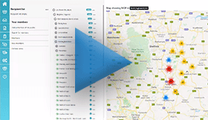 | We held a Police-only Practitioner Group meeting earlier this month which was very helpful with some great feedback provided regarding the new interface. The system is approaching a point where we can provide a live environment for the V4.0 version.  Warwickshire have agreed to be a test pilots for the first launch and we are working closely with them to agree the final requirements, train some initial administrators and build the first V4 front end site and registration process. I am confident that the system will be live in November with the Rapport admin following in December.  You can review a 20 minute overview of the V4 interface from this link. This gives a feel for the speed of the system and for some, the first glimpse of the new user interface which makes managing responses, finding data and sending messages so much easier.

Clare will be calling you!
 | Don’t be scared, it’s all good! Clare has been with VISAV forever and is the real boss behind the scenes. She has agreed to help me with supporting you with more regular direct contact.  Clare will be giving you a call over the next few weeks just to check that we are looking after you properly and not missing something that you need. Clare is not technical but is a great listener and very organised. She can access our ticket system to check on issues you and your colleagues have raised plus she can highlight tasks on your behalf in our weekly meetings.  Please give me a good report or I will be in trouble (again)!

Alert Messages Sent:
 | We are on target to deliver around 8 million emails on your behalf in October, which represents a typical month and usual for this time of year. We reached a new milestone of delivering over 1 million emails to Alert subscribers in a single day on 27th July and broke another record that month with a total of 10.7 Million emails sent in one month!.
Alert emails sent per month
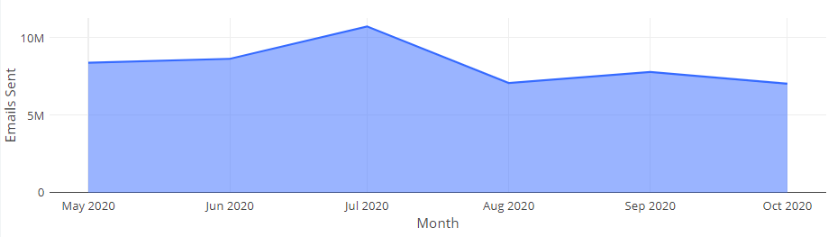

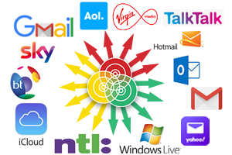 | Delivering this many emails requires a close working relationship with the main email providers, otherwise messages are marked as spam, queued for hours or simply rejected. We are well known to the big players now, they understand that we are a dedicated service for Police and blue light services and I am delighted to say, our size and proven systems mean that your messages are delivered far quicker and more reliably than any single system could manage.  I have included a quick breakdown below of the main email providers that we collectively sent through during September.  The important factor here is to keep your Comms issues low and don’t just reactivate accounts. Remember, your Neighbourhood Watch MSAs can help with this work if you encorage your new members to opt-in to Neighbourhood Watch as an Information Provider.
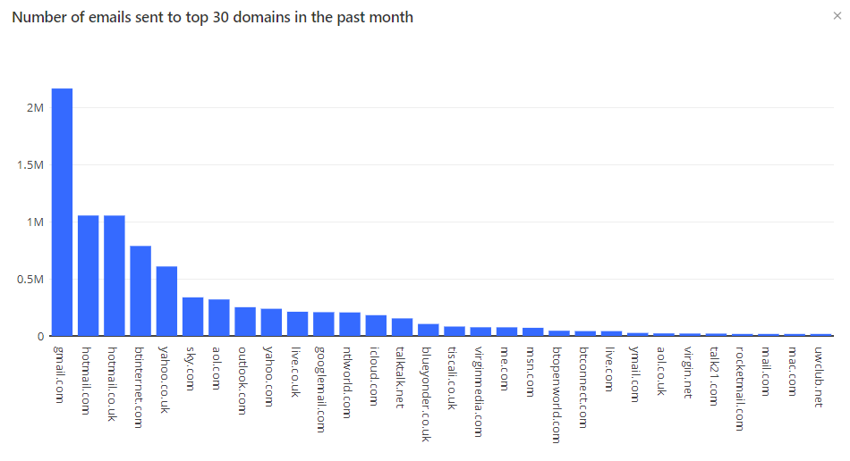

Your Database Engagement:
 | We have produced a new dashboard that shows the percentage of your database that has been contacted by any method (email, voice or text), by force area. This shows data for the previous calendar month and includes all users visible to “the police” as an information provider (including those with comms issues and those who are incommunicado).  Durham, Sussex, Surrey Cambridgeshire and Hampshire are consistantly top in this area which reflects on the work they do to keep their database updated and accurate as well as their commitment to send messages to the whole database.
Fig 2. Percentage of users contacted in September by force area:
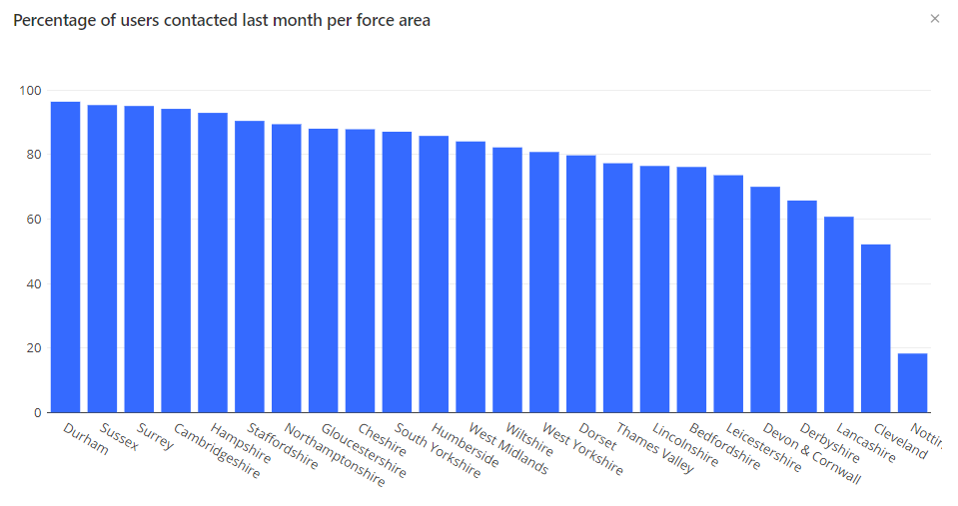

Neighbourhood Watch SPOCs:

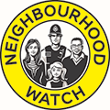 | In order to support the continued healthy relationship with the Neighbourhood Watch Central Support Team (CSP) and local associations we have been asked to provide the CSP with a list of the most appropriate Police contacts for them to liasie with ragarding neighbourhood Alert and neighbourhood Watch matters. Could you please let me know who your local Neighbourhood Watch SPoC/liaison is.  I have a good idea who this could be in each area but we want to compile a definitive list of the key points of contact between each force and their local NWN network. I would be grateful if you would email this information to chris@visav.co.uk.

That’s it for this update. As ever, please don’t hesitate to get in touch if you have any queries.

Mike Douglas
Product Director: Neighbourhood Alert
VISAV Limited
( 0115 924 5517 Ext 224
( 0115 8384636 (DDI)
( 07771 557788 (Mobile)
W www.NeighbourhoodAlert.co.uk
/// police.broad.tigers

VISAV Ltd | Sherwood Business Centre | 616a-618a Mansfield Road | Sherwood | Nottingham | NG5 2GA | Company No: 04511143 | Data Protection Registration: Z8862537

This message may contain information which is confidential or private in nature, some or all of which may be subject to legal privilege. If you are not the intended recipient, you may not peruse, use, disseminate, distribute or copy this message or any file which is attached to this message. If you have received this message in error, please notify the sender immediately by e-mail or telephone and thereafter return and/or destroy the message.
 Help cut carbon...please don't print this email unless you really need to.


