NEIGHBOURHOOD ALERT DEV BOARD UPDATE: 58

Date: 15th July 2020

Dear Mike Douglas,
Email: mike@visav.co.uk
Note: You are receiving this email circular because you are listed as a key contact involved with your organisation’s Neighbourhood Alert system, including senior administrators and members of the Practitioners’ Group. If you feel you should not be on this list, please reply to feedback@neighbourhoodalert.co.uk and I will remove you.

View an archive of previous updates here

Welcome to the latest Dev Board update bulletin. It’s been another busy couple of weeks in the business! This update includes a “Save The Date” for a Version 4 glimpse, some growth stats and updates to some of our survey facilities as well as some boring stuff about things we do in the background to keep you looking awesome.

Mike

Contents
V4 Update and “Save The Date” 2
Updates to Enhanced Survey Tool: 2
Neighbourhood Watch Development and MSA’s: 3
Database Growth Update 4
Junk Mail Reporting Program (JMRP): 4
Smart Network Data Services (SNDS) Program: 5
Dev Board Archive Update: 5

V4 Update and “Save The Date”

Development of V4 has been progressing well over the past few weeks with an emphasis on the messaging console. Some of the new features are simply awe inspiring and I cannot wait to be able to show them to you in the coming weeks.
With this in mind we have set up a quick online “preview” demonstration for next Friday for those of you that would like to have a glimpse of the new message inbox and replies management system. Chris will be sending further details out to the Practitioner Group soon but I have included the Teams login details below.

__________________________________________________
Join Microsoft Teams Meeting 10 am Friday 24th July 2020.
Learn more about Teams | Meeting options

For those who cannot (yet) access Teams, you can view the meeting via your web browser with the link below and we have a dial in phone option as well.
https://meet57018359.adobeconnect.com/_a980151297/alert/?refresh-parent=true
Dial in (back up), 0115 8384637, Access code: 0138896#
__________________________________________________

Updates to Enhanced Survey Tool:

Development continues on the “Enhanced Survey Module” which many will know as “Humber Talking”. I will update those clients in more detail separately but (just to make those that do not have that tool yet jealous), here is a quick summary of the latest tweaks:
- Clearer labelling on the interactive results map highlighting which issue you are viewing
- You can now toggle on/off the different respondent types i.e. incident location.
- After input from Leicestershire Police, we now show an “other respondents” option on the map. This shows each highlighted issue compared with the overall number of respondents and those that do not currently see that item as an issue.
- We will soon display the Ward areas on the map which will help to gain a further perspective of the results geographically.

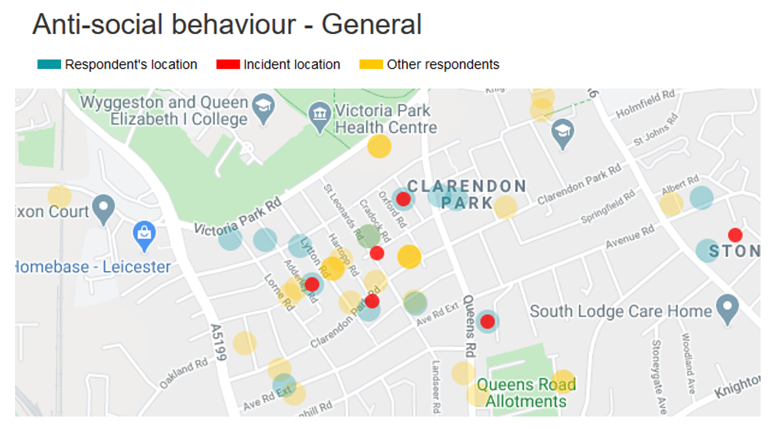

Neighbourhood Watch Development and MSA’s:

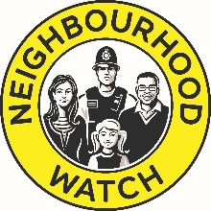 | Relating to Version 4 development, we continue to work with the NWN IT Working Group and have been conceptualising the layout of the Neighbourhood Watch tools in line with our latest thinking regarding the rest of the V4 layout and processes.  Our vision is to have the scheme management, mapping, membership and communication fit seamlessly with your other Alert tools so training, partnership working and MSA support is simple and seamless. We have scheduled a meeting with the NWN IT Group this coming Friday to demonstrate our ideas and gain feedback before we continue the development work for this next phase.
We recently sent a gift and thank you letter to Neighbourhood Watch MSA’s to coincide with Neighbourhood Watch Week and to show our appreciation for the hard work that these volunteers do on all of our behalves on a daily basis to keep the Alert database up to date.
In conjunction with this we have also created a dedicated “Valuing MSA’s” page on the Neighbourhood Alert website with some biographies and quotes from some of the top MSA’s in the country. You can view the page here. If we have missed anyone off that you feel should be included or you have a supportive comment that you would like to add to this page, please send the details through to sue@visav.co.uk.

Database Growth Update

We are now pushing 840,000 members across the UK and from the analysis of the 104k responses to our national survey we know on average a recipient passes your Alerts on to 18.2 further people. This means we can reach over 15 million UK residents with a national message (22% of the UK population) and have an incredible reach over social and other media channels like “InYourArea” and SafeLand. Well done to all of you for your incredible work in continuing to grow your engagement, especially in these difficult times.

It would be remiss of me to not highlight the continued great work by West Midlands Police on their growth of WMNow.co.uk registrations; even though we automatically delete all un-registered users once a month, their growth rate is superb.
I should also highlight the incredible job Leicestershire Police are doing to grow their database now they are on board with the Enhanced Survey Tool, they have a new website design (https://www.neighbourhoodlink.co.uk/), a simple registration and their own “Talking” programme. What is also interesting is that the top six forces for growth in June all use our enhanced survey module.

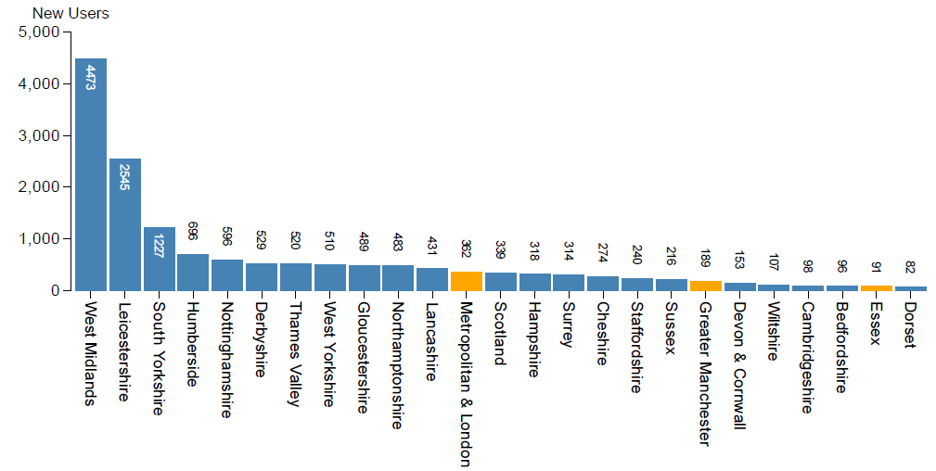

Junk Mail Reporting Program (JMRP):

Being vigilant about users who mark your e-mail as unwanted or the types of messages that are being marked as unwanted is vital in preserving your email reputation and ensuring that emails continue to be delivered successfully.
We take care of 90% of the time-consuming processes that would ordinarily make managing a large database of users prohibitive, especially in these austere times. However, the role you, and your brilliant Volunteers and MSAs play in managing Comms issues and Incommunicados correctly is vital. Don’t just reactivate blocked accounts, check those email details first, delete un-verified accounts if they have ignored a couple or re-requests etc.
Neighbourhood Alert is a registered member of the Junk mail reporting program (JMRP) and as such we continue to update our blocking and monitoring processes to protect your reputation and remove blocked accounts quickly. This means those “Comms issues” do increase now and again but for good reason.

Smart Network Data Services (SNDS) Program:

The SNDS program provides data about traffic seen originating from your registered email account, such as mail volume and complaint rates. The data is built from the log files of the inbound mail machines and other servers at Outlook.com and Microsoft and represents information about the traffic from your mail servers to Outlook.com users.
This is another programme that Neighbourhood Alert manages on your behalf in the background to save you time and protect your reputation. Your management of Comms issues is again vital to keep things on track. For more information about this program, refer to https://postmaster.live.com/snds/FAQ.aspx.

Dev Board Archive Update:

 | We have updated the Dev Board archive where you will now find a copy of all previous 57 Dev Board bulletins. So if you want a recap on items such as V4, Rapport, the National Survey, NW scheme mapping, InYourArea or any of the numerous other items that have been covered, the archive is the place to visit and you can find it here.
That’s it for this week. As ever, please don’t hesitate to get in touch if you have any queries.

Mike Douglas
Product Director: Neighbourhood Alert
VISAV Limited
( 0115 924 5517 Ext 224
( 0115 8384636 (DDI)
( 07771 557788 (Mobile)
W www.NeighbourhoodAlert.co.uk
/// police.broad.tigers

VISAV Ltd | Sherwood Business Centre | 616a-618a Mansfield Road | Sherwood | Nottingham | NG5 2GA | Company No: 04511143 | Data Protection Registration: Z8862537

This message may contain information which is confidential or private in nature, some or all of which may be subject to legal privilege. If you are not the intended recipient, you may not peruse, use, disseminate, distribute or copy this message or any file which is attached to this message. If you have received this message in error, please notify the sender immediately by e-mail or telephone and thereafter return and/or destroy the message.
 Help cut carbon...please don't print this email unless you really need to.

